MONITOR – CAD 2D

ADINA – DIANA VĂLCĂUAN

# The real object

* ***MAIN VIEW***

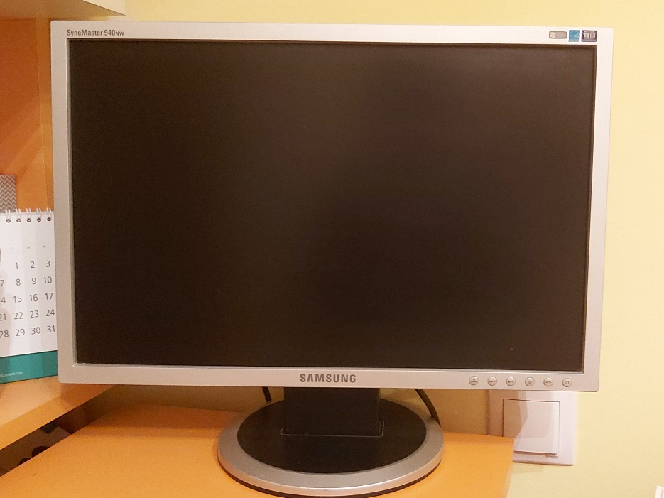

* ***TOP VIEW (SECONDARY VIEW)***

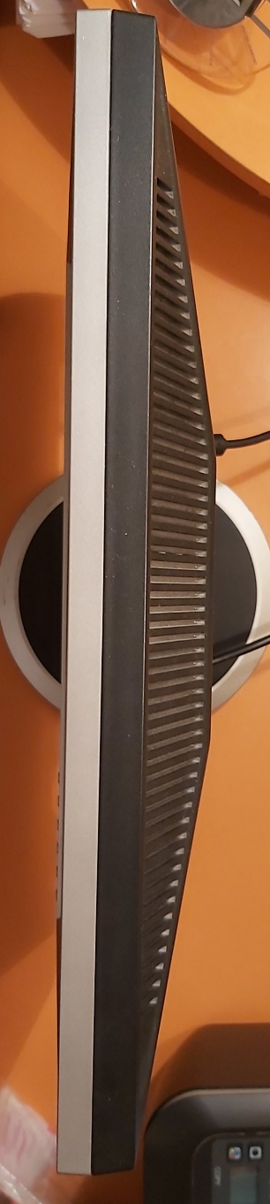

# List of commands

* Snap (set at 0.5, but sometimes at 0.2, 0.1 for small details)
* Grid (set at 0.5)
* Polyline
* Line
* Circle
* Arc
* Elliptical Arc
* Text
* Hatch ANSI32
* Trim
* Move
* Copy
* Mirror
* Dimension (for checking)
* Donut
* Pan
* Group (for the buttons)

# AutoCAD generated project

